# 1. INTRODUCTION

## 1.1 Project Overview

Detecting online payment fraud is a critical endeavour that demands a comprehensive approach encompassing various stages, from data collection to continuous monitoring and improvement. The initial stage entails the meticulous compilation of a comprehensive dataset, encompassing legitimate and fraudulent transactions. This dataset, reflective of real-world scenarios, incorporates transaction attributes such as time, type of transaction, amounts etc, serving as the foundational element for subsequent model development.

Following data collection, a rigorous data preprocessing phase ensues. Addressing missing values, outliers, and inconsistencies ensures a refined dataset. This sets the stage for Exploratory Data Analysis, a discerning examination of the unique features characterizing both legitimate and fraudulent transactions, elucidating patterns, trends, and correlations within the dataset.

A pivotal decision in the project lies in the selection of a suitable machine learning algorithm for fraud detection. In this project, we are training 5 different models based on 5 different machine learning algorithms and comparing them based on their accuracy. The chosen model undergoes meticulous training on a segmented dataset, with hyperparameters fine-tuned to optimize performance. Model evaluation, conducted on a separate testing dataset, meticulously considers the business implications of false positives and false negatives.

Upon successful evaluation, the model transitions to deployment, seamlessly integrating into the production environment. It becomes an integral component of the online payment system, analyzing transactions in real-time. This deployment marks the initiation of a continuous monitoring and improvement phase, ensuring the model remains adept at discerning evolving fraud patterns through regular updates with new data and is done on business level.

1.2 Purpose:

Imagine navigating the online world where every click, every purchase is vulnerable to cunning tactics of hackers. As we embrace the convenience of digital transactions, the threats of online payment fraud loom larger than ever. Hackers, with tactics like identity theft and phishing attacks, are constantly evolving.

In this dynamic landscape, online payments fraud detection emerges as a vital guardian. It stands as a formidable defence against the cunning tactics of fraudsters, preserving the sanctity of digital transactions. As financial activities migrate to online platforms, the necessity for robust fraud detection becomes paramount.

Here are some additional points which address the compelling necessity of solving the issue of payment frauds -

### • Risk Mitigation

Protect financial institutions, businesses, and users from financial losses associated with fraudulent transactions.

### • Enhance Security

Strengthen the overall security of online payment systems by incorporating advanced machine learning algorithms to detect suspicious activities.

### • Improve User Trust

Increase user confidence in online transactions by creating a secure environment that actively prevents and addresses fraudulent behaviour.

### • Operational Efficiency

Reduce the workload on manual fraud detection teams by automating the identification and blocking of potentially fraudulent transactions.

### • Cost Savings

Minimize financial losses attributed to fraudulent activities, which can result in significant cost savings for businesses and financial institutions.

### • Customer Satisfaction

Provide a seamless and secure online payment experience for customers, enhancing overall satisfaction and loyalty.

### • Compliance

Ensure compliance with industry regulations and standards related to online transactions and financial security.

### • Real-Time Detection

Detect and respond to fraudulent activities in real-time, preventing unauthorized access and transactions.

### • Adaptability to Emerging Threats

Utilize machine learning to adapt to evolving fraud patterns and stay ahead of new and sophisticated fraud techniques.

### • Data-Driven Insights

Gain valuable insights into transaction patterns, user behaviour, and fraud indicators, which can inform future security measures and business strategies.

### • Proactive Approach

Take a proactive stance against fraud, identifying and blocking suspicious activities before they result in financial losses.

### • Global Impact

Contribute to the overall reduction of online payment fraud on a global scale, creating a safer digital ecosystem for users and businesses worldwide.

### • Operational Continuity

Ensure the continuous and secure operation of online payment systems, safeguarding businesses and users from potential disruptions caused by fraud.

### • Demonstrate Technological Prowess

Showcase the organization's commitment to leveraging advanced technologies like machine learning for the enhancement of security measures.

# 2. LITERATURE SURVEY

2.2 Existing problem:

Business-Related Challenges:

## • False Positives and Negatives

Striking the right balance between false positives and false negatives is crucial for business operations. False positives disrupt legitimate transactions, impacting user experience, while false negatives expose the business to financial risks.

## • Imbalanced Datasets

Dealing with imbalanced datasets is a business challenge as it influences the model's ability to effectively identify and prevent fraud. The disproportionate number of legitimate transactions may lead to overlooking potentially fraudulent activities.

## • Integration with Legacy Systems

Integrating modern machine learning models with existing legacy fraud detection systems is a practical challenge for businesses. Legacy systems may require extensive modifications to accommodate the flexibility and adaptability demanded by machine learning approaches.

## • Privacy Concerns

Balancing accurate fraud detection with user privacy is a business imperative. The collection and analysis of sensitive data must align with privacy regulations to maintain trust and compliance.

## • Continuous Model Monitoring and Updating

The need for continuous monitoring and updating is intrinsic to business operations. Failing to adapt to emerging fraud patterns can result in outdated models, diminishing the effectiveness of fraud detection over time.

## • Cost of Implementation

The cost of implementing and maintaining a robust machine learning-based fraud detection system is a significant business consideration. Allocating resources for data acquisition, model development, and ongoing monitoring is essential.

AI-Related Challenges:

## • Adversarial Attacks

Adversarial attacks pose a specific challenge to the capabilities of machine learning models. Addressing these attacks requires advancements in AI to fortify models against sophisticated manipulation.

## • Concept Drift

Concept drift, reflecting the dynamic nature of fraud, is an AI challenge. Ensuring that machine learning models can adapt to evolving fraud patterns over time demands continuous innovation in AI algorithms.

## • Data Quality and Availability

The efficacy of AI-driven fraud detection is contingent on the quality and availability of data. Ensuring a robust pipeline for data acquisition and pre-processing is integral to the success of AI models.

## • Interpretability and Explainability

The interpretability and explainability of complex machine learning models, particularly deep neural networks, is an AI challenge. Balancing sophistication with the ability to interpret model decisions becomes crucial for trust and compliance.

## • Scalability

Scalability is a specific AI challenge as transaction volumes increase. Enhancing the scalability of AI models to handle large amounts of data in real-time without sacrificing performance is essential.

## 2.3 References

* Kaggle
* Research Gate
* Science Direct

## 2.4 Problem Statement Definition

The surge in internet and e-commerce activities has ushered in a corresponding increase in online credit/debit card transactions, subsequently giving rise to a growing concern: the proliferation of fraudulent activities. The heightened usage of credit/debit cards has exacerbated the vulnerability to fraud, necessitating effective detection methods. While various approaches exist, they often grapple with accuracy issues and possess specific drawbacks. Notably, these methods are triggered by changes in transaction behavior, instigating predictions and subsequent investigative processes.

Compounded by the substantial volume of data associated with credit/debit card transactions, the challenge of fraud detection persists. To address this issue, the proposed method aims to rectify the credit/debit card fraud detection problem. The goal is to enhance accuracy, overcome the limitations inherent in existing approaches, and dynamically adapt to deviations in transaction conduct. With a focus on innovation, this proposed method seeks to fortify the security of online transactions, ensuring a resilient solution that aligns with the evolving landscape of e-commerce. Ultimately, it endeavours to safeguard businesses and users from the escalating threat posed by fraudulent activities.

# 3. IDEATION & PROPOSED SOLUTION

## 3.1 Empathy Map Canvas

https://drive.google.com/file/d/1kKab5uuLwRFBL0DON_FEbMxksMr8eflw/view?usp=sharing

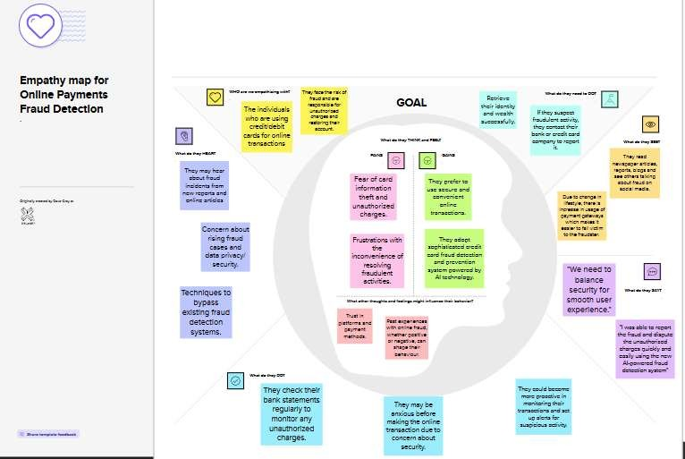

## 3.2 Ideation & Brainstorming

https://drive.google.com/drive/folders/1_D-

r5idFDDMO8NGaaXdHMNy8dMMCokMB?usp=sharing

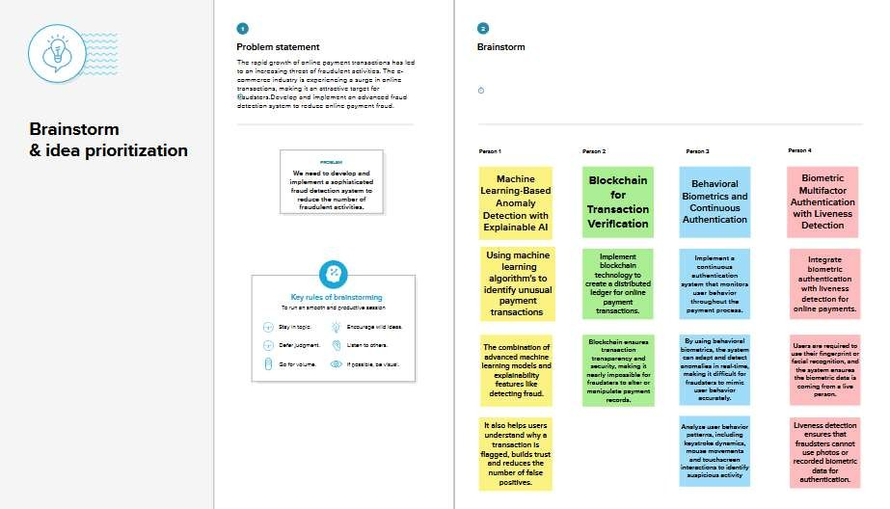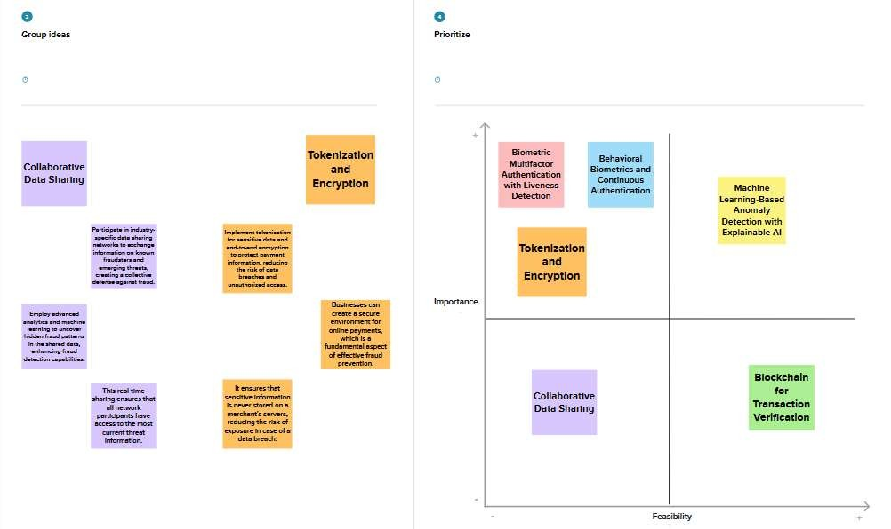

# 4. REQUIREMENT ANALYSIS

4.1 Functional requirement:

## • Data Collection and Integration

The system shall collect real-time transaction data from multiple sources, including payment gateways, e-commerce platforms, and external databases.

## • Machine Learning Model Integration

The system shall integrate multiple machine learning models for fraud detection, with the capability to train, validate, and deploy these models as needed.

## • Real-time Fraud Detection

The system shall continuously analyse incoming transactions in real-time to identify potentially fraudulent activities using the integrated machine learning models and rule-based systems.

## • Alerting and Notification

The system shall send real-time alerts and notifications to designated stakeholders when suspicious or potentially fraudulent transactions are detected, including details of the transaction and risk level.

## • Reporting and Compliance

The system shall generate comprehensive reports and analytics to monitor fraud detection performance, identify trends, and ensure compliance with relevant data protection and privacy regulations.

## • Audit Trail and Documentation

The system shall maintain a detailed audit trail of all system activities, including user access and model updates, for security and compliance purposes.

The system shall provide documentation for system administrators and end-users, including user guides and training materials.

4.2 Non-Functional requirements:

## • Usability

The system must have an intuitive and user-friendly interface for users with varying levels of technical expertise.

Keyboard navigation and accessibility features must be available to aid users with disabilities.

## • Security

The system should enforce strong authentication and authorization mechanisms to prevent unauthorized access.

All sensitive data should be securely encrypted during transmission and storage.

Security measures such as intrusion detection and prevention systems should be in place.

## • Reliability

The system should demonstrate high reliability with a minimum acceptable uptime percentage. It should have backup and disaster recovery mechanisms to minimize downtime during system failures.

## • Performance

The system must efficiently process a high volume of transactions in real-time without significant latency.

Response times for fraud detection should meet predefined thresholds to ensure timely action on suspicious transactions.

## • Availability

The system should be always available, with minimal downtime, to support uninterrupted fraud detection.

Availability should meet predefined service level agreements (SLAs).

## • Scalability

The system must be designed to scale horizontally and vertically to accommodate increasing transaction volumes.

Additional computational resources should be easily added to handle peak workloads.

# 5. PROJECT DESIGN

## 5.1 Data Flow Diagrams & User Stories

https://drive.google.com/file/d/1PS28m55jCrtc58oX7kI1O0urua121mba/view?usp=sharing

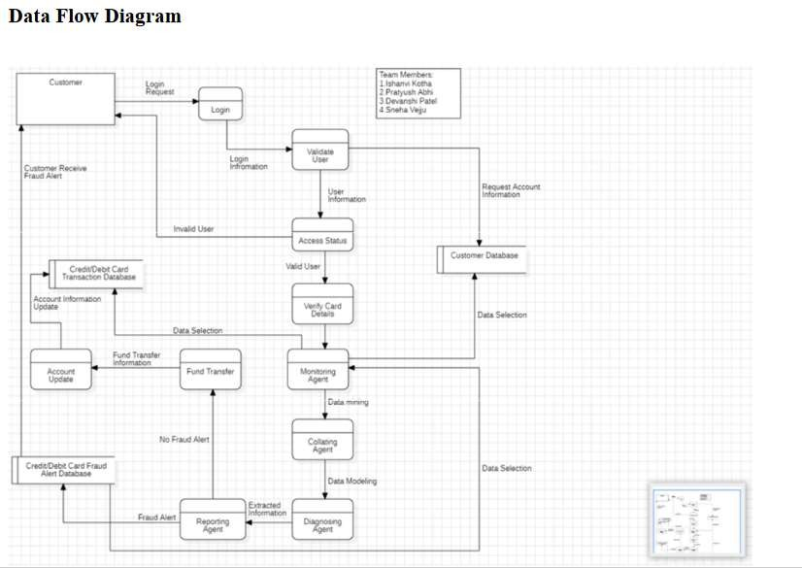

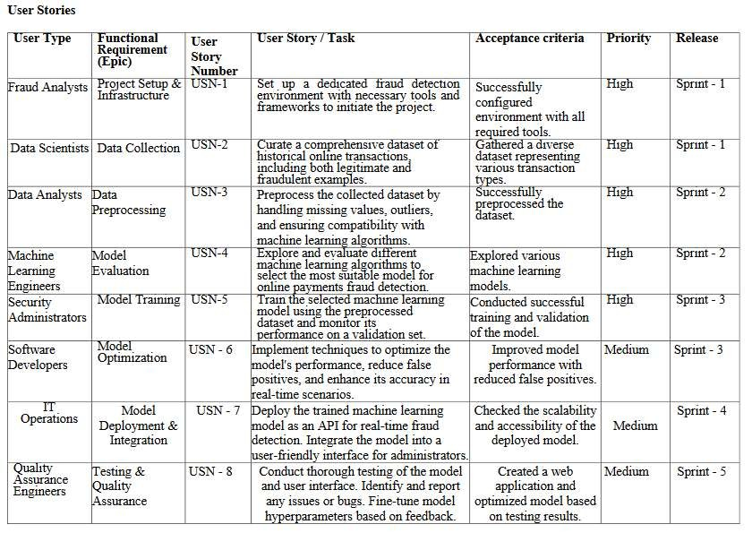

## 5.2 Solution Architecture

https://drive.google.com/file/d/1864NQPlXMZVs5-EY6gZQGQxScsjmc0uy/view?usp=drive_link

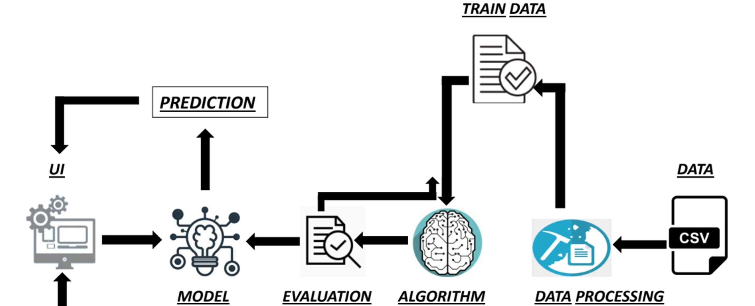

# 6. PROJECT PLANNING & SCHEDULING

6.1 Technical Architecture https://drive.google.com/file/d/1oF1WQkejsr16suAZsmOmXMNhuTuYn7NM/view?usp=sharing

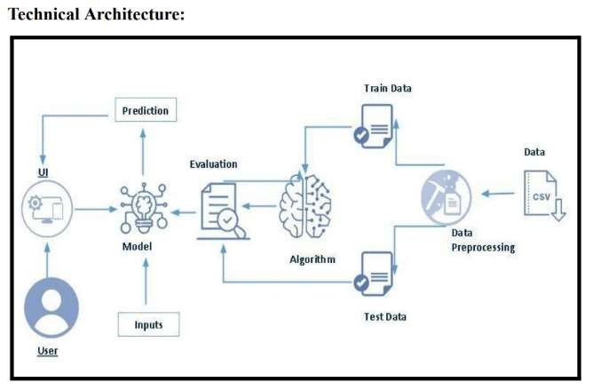

## 6.2 Sprint Planning & Estimation

https://drive.google.com/file/d/1IysHxrB1SSBUfHA5Zkjc9FWtnSWs2grZ/view?usp=sharing



6.3 Sprint Delivery Schedule https://drive.google.com/file/d/1IysHxrB1SSBUfHA5Zkjc9FWtnSWs2grZ/view?usp=sharing

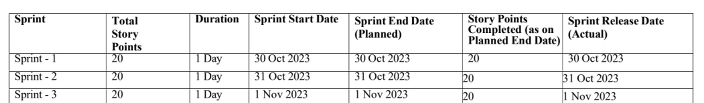

# 7. CODING & SOLUTIONING (Explain the features added in the project along with code)

The entire code can be accessed through the Git Repo or Google Drive link provided below

Google drive – https://drive.google.com/drive/folders/1Cf1qemsnkJ-ZgK8F5OHUxnWNRXE8Ba5M?usp=drive_link GitHub Repo – smartinternz02/SI-GuidedProject-615037-1699457699 (github.com)

## 7.1 Feature 1

### • Under sampling

In addressing the highly imbalanced nature of my fraud detection dataset, we employed the technique of under sampling to rectify the skewed distribution between legitimate and fraudulent transactions.

The imbalance, characterized by a significantly higher number of legitimate transactions compared to fraudulent ones, can potentially compromise the effectiveness of the fraud detection model. Under sampling involves randomly removing instances of the majority class (legitimate transactions) to create a more balanced dataset, allowing the model to better discern patterns associated with the minority class (fraudulent transactions).

By doing so, under sampling aims to prevent the model from being biased towards the majority class, enhancing its ability to accurately identify and classify instances of fraud. This strategic approach ensures a more robust and fair training environment, ultimately contributing to the model's efficacy in addressing the challenges posed by imbalanced data in the context of fraud detection.

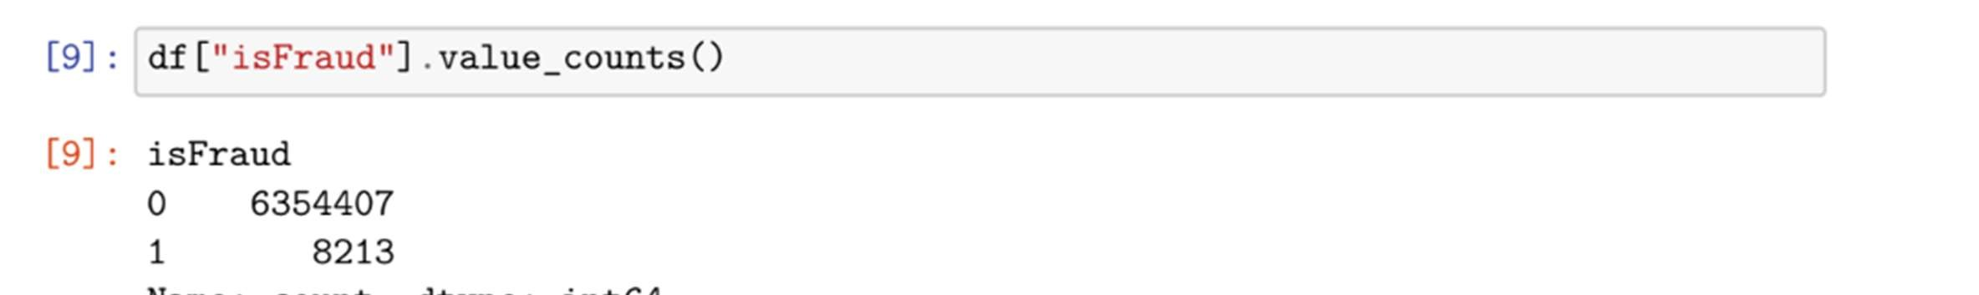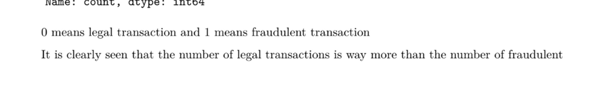

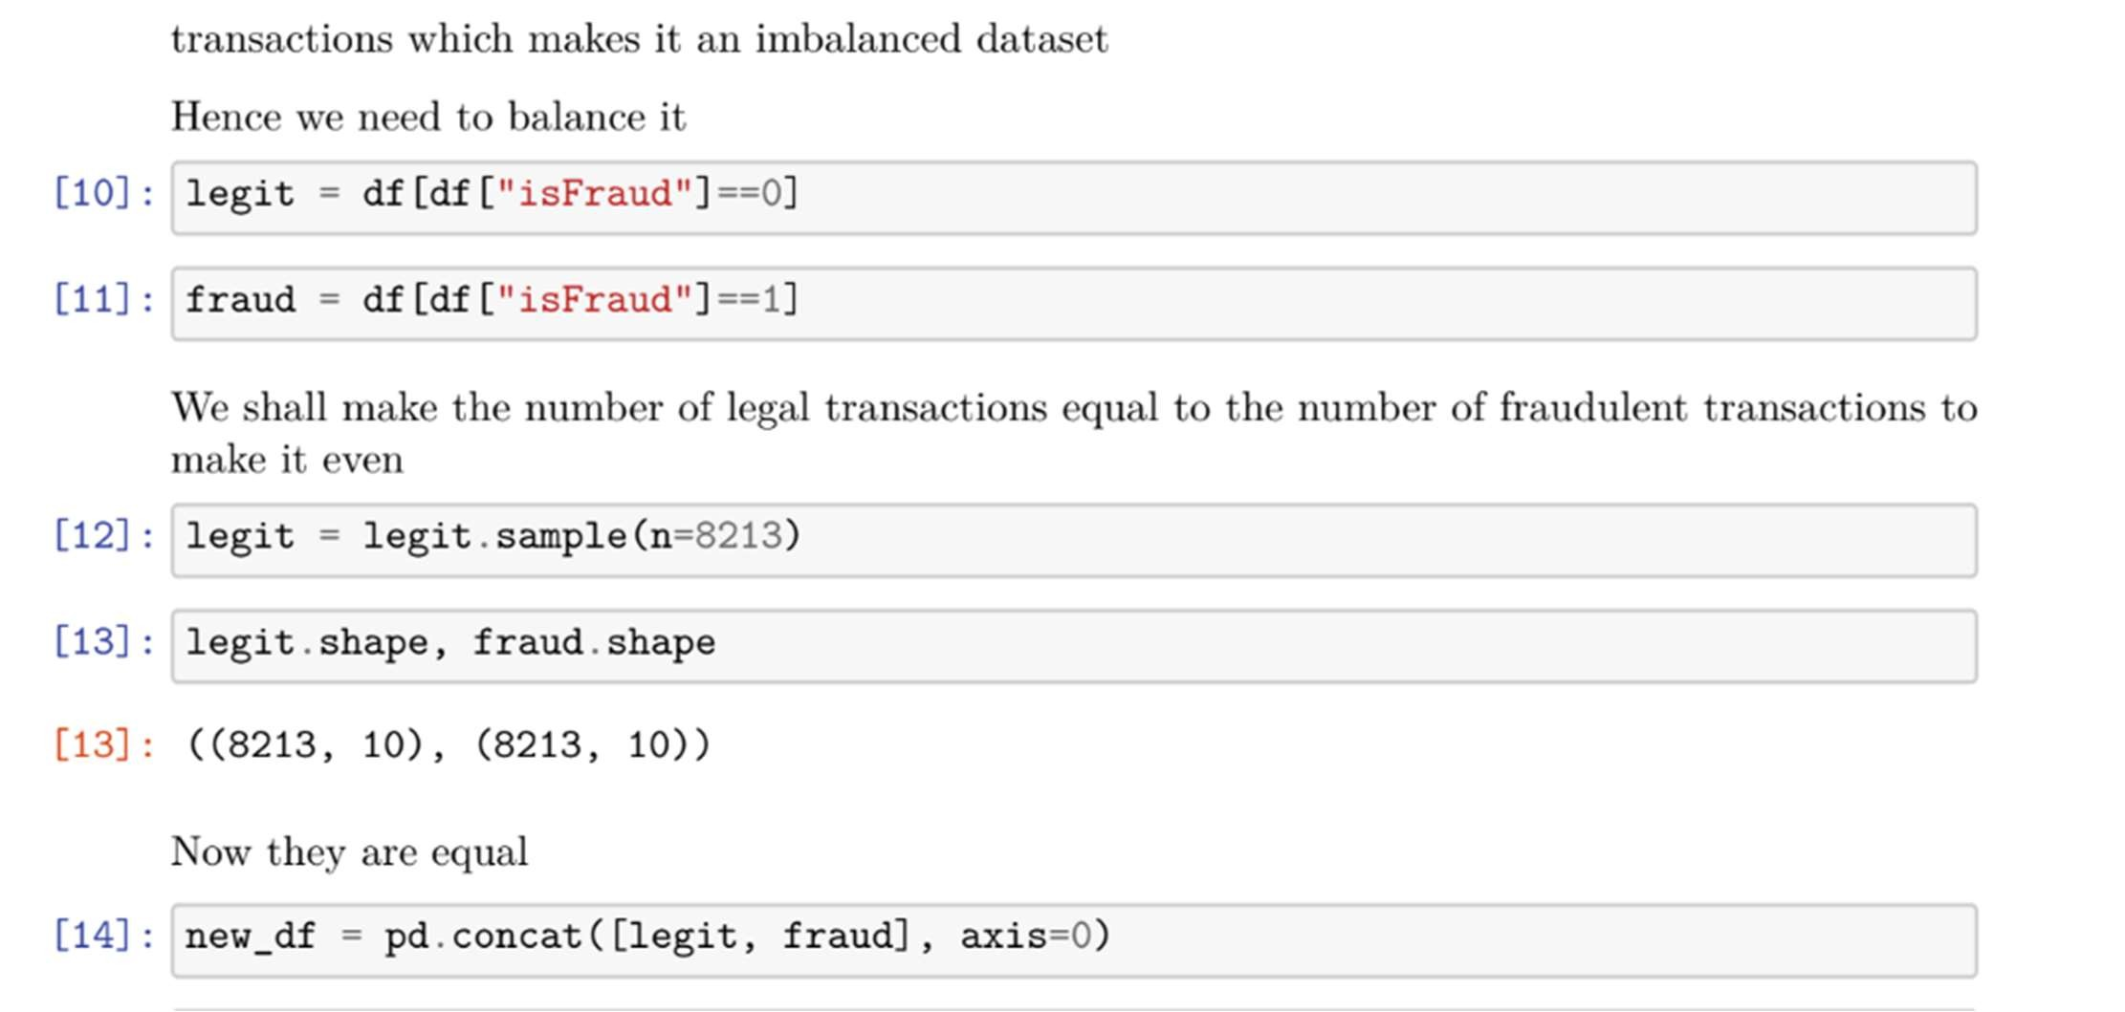

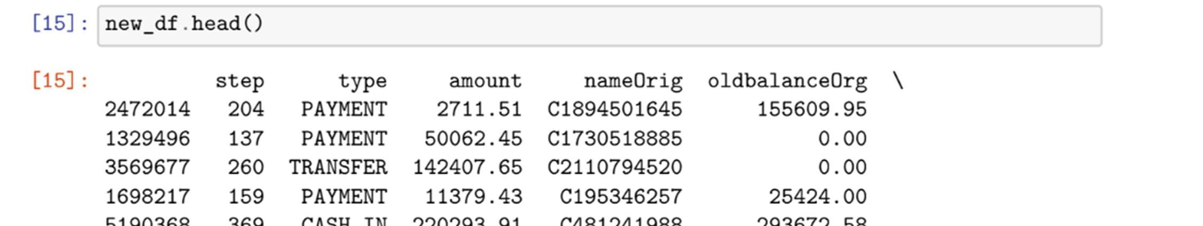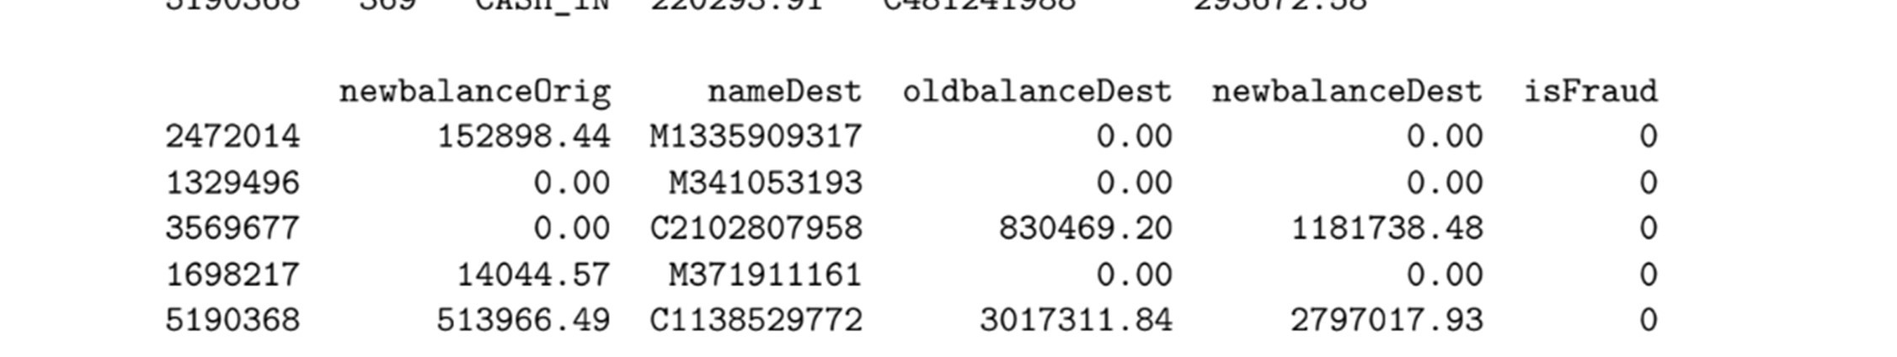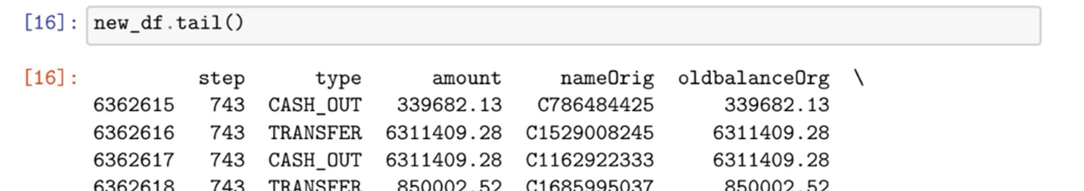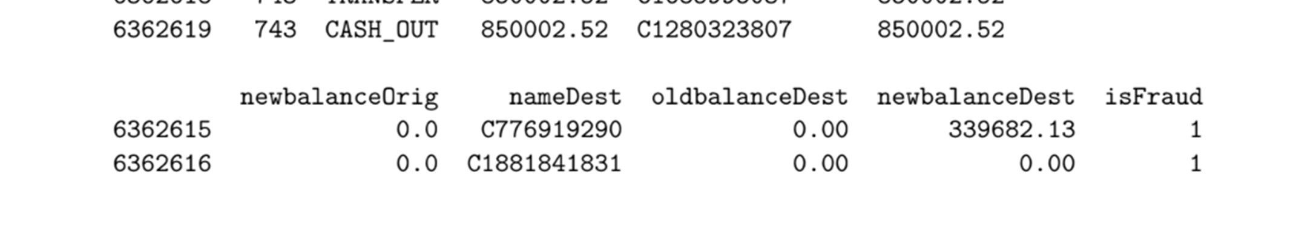

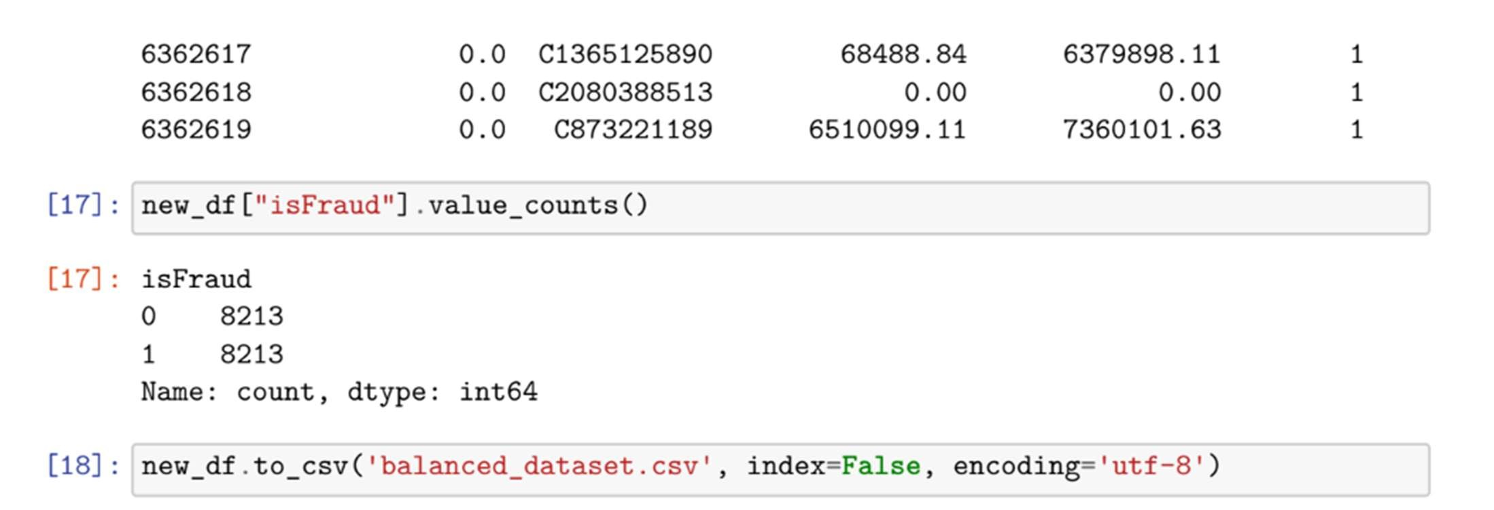

## 7.2 Feature 2

### • Training models on different machine learning algorithms to pick the best training model

1. Random Forest Regressor

Random Forest constructs an ensemble of decision trees, where each tree is trained on a random subset of the data. The final prediction is an average or voting mechanism, providing a robust and accurate result.

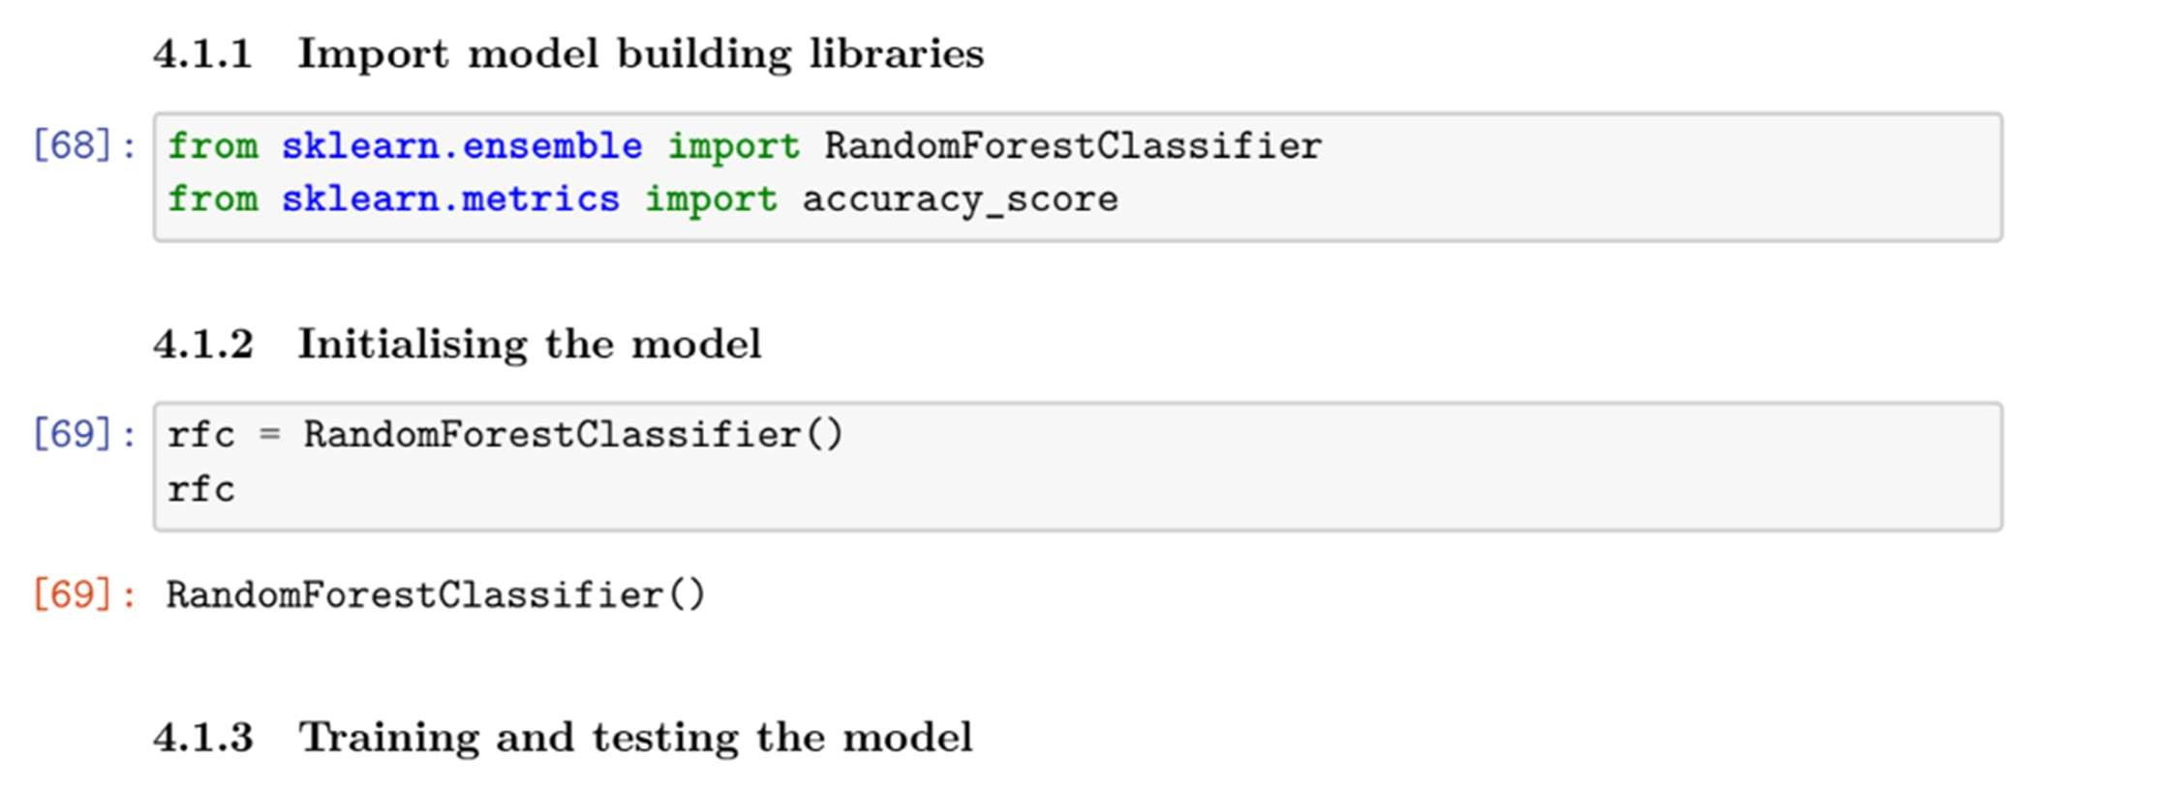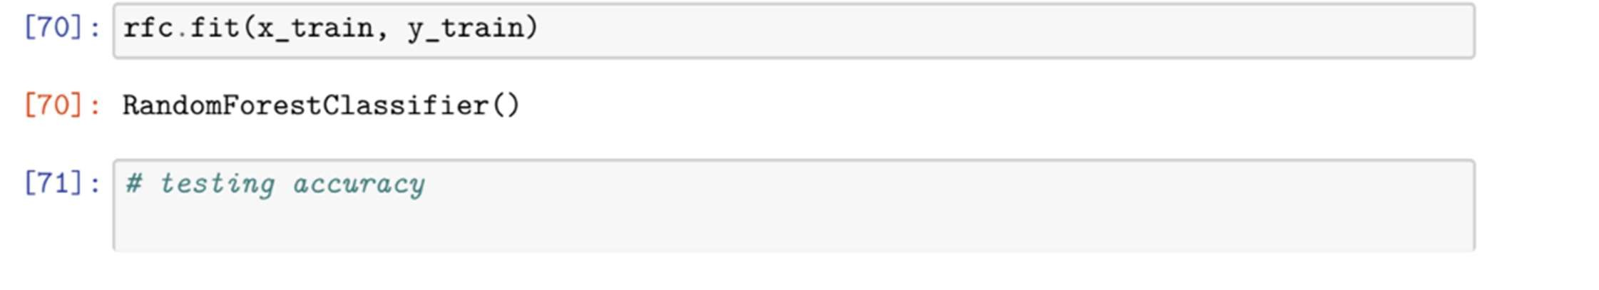

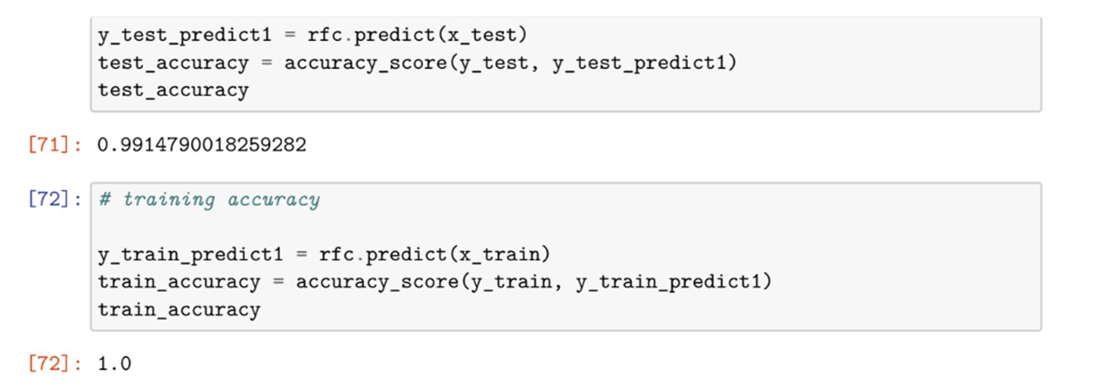

1. Decision Tree Classifier

Decision Trees work by recursively partitioning the dataset based on features, creating a tree structure where each node represents a decision based on a specific feature, ultimately leading to a classification or regression outcome.

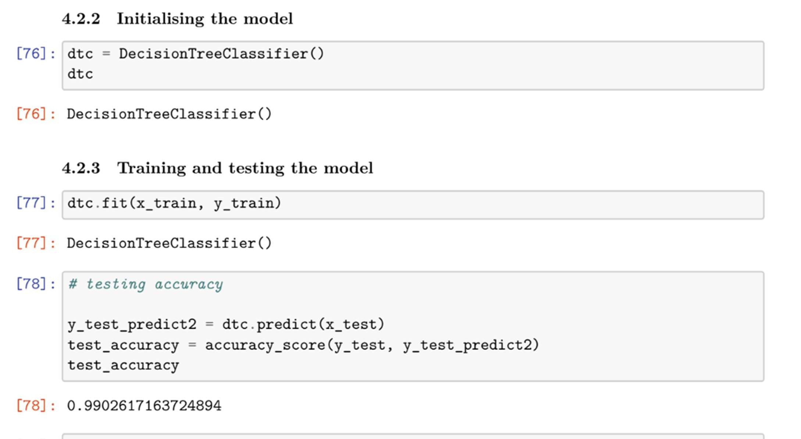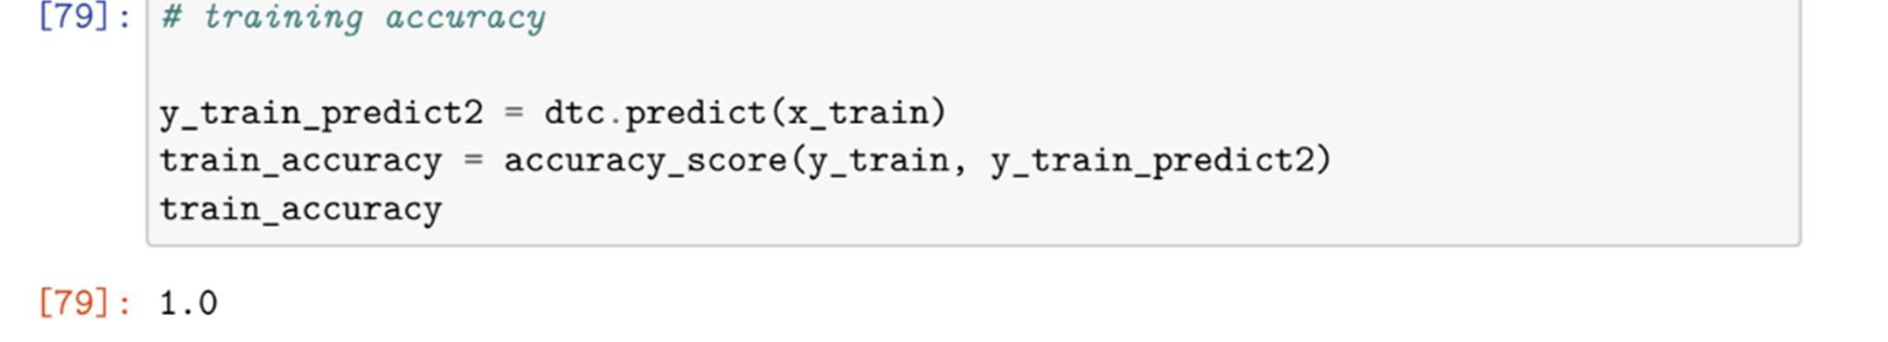

1. Support Vector Machine

SVM classifies data points by finding the hyperplane that best separates different classes in the feature space. It aims to maximize the margin between classes, leading to effective classification, especially in high-dimensional spaces.

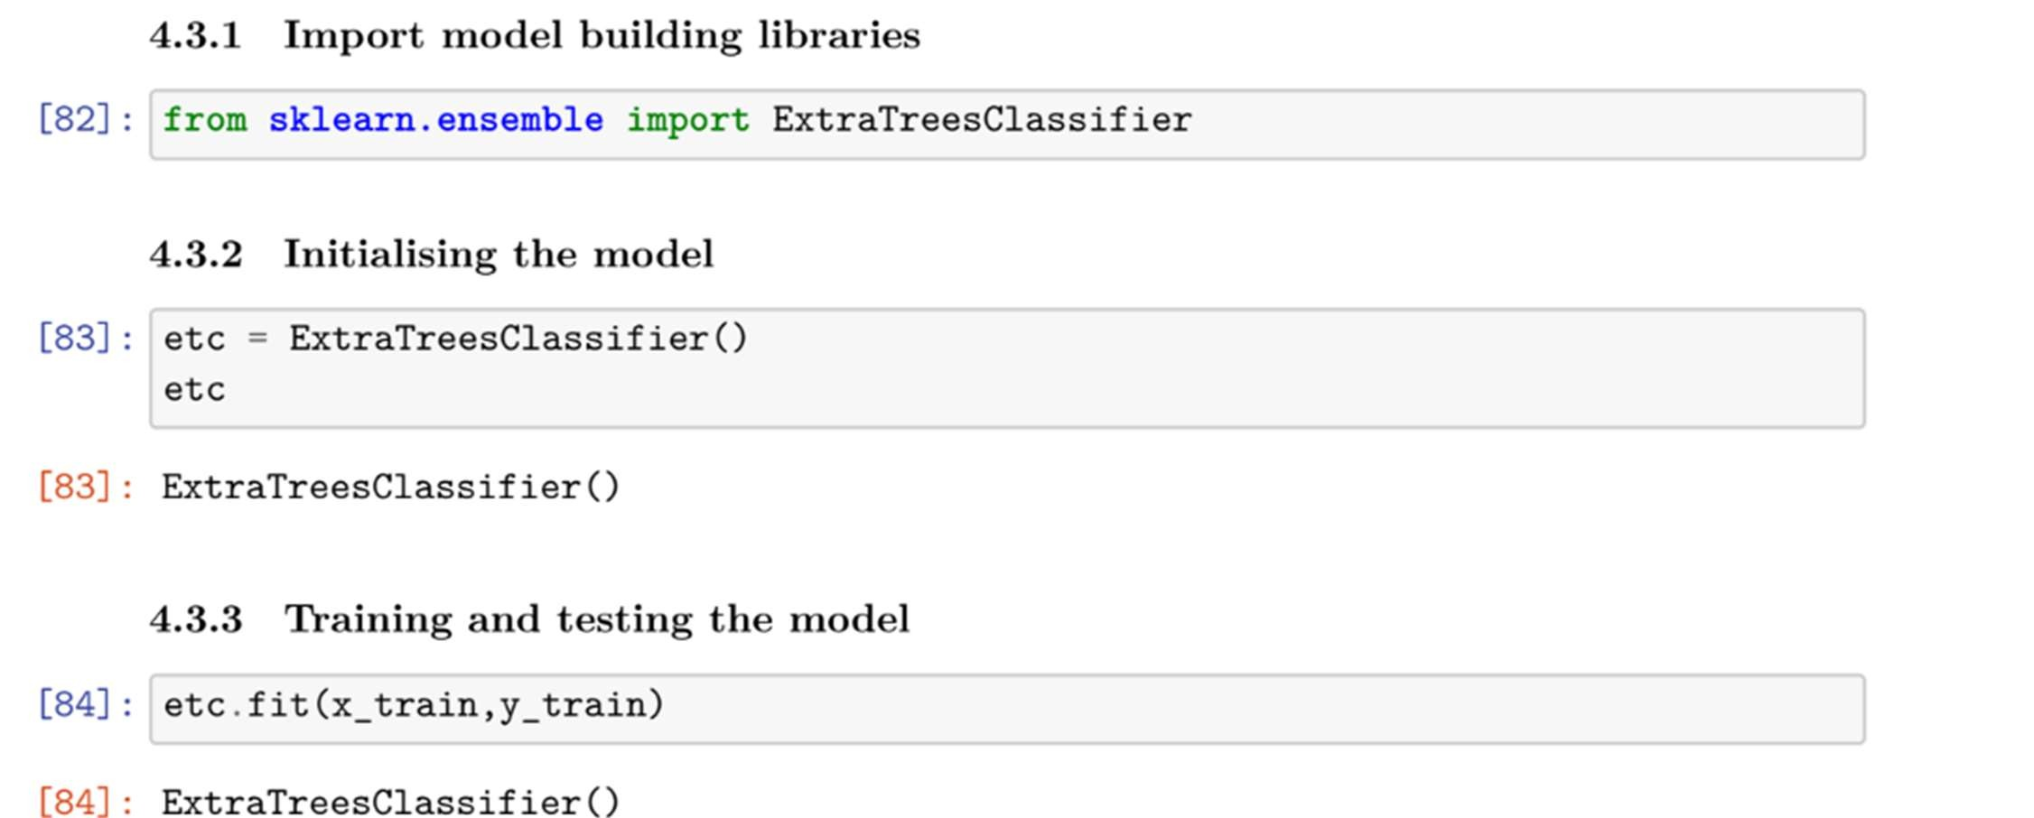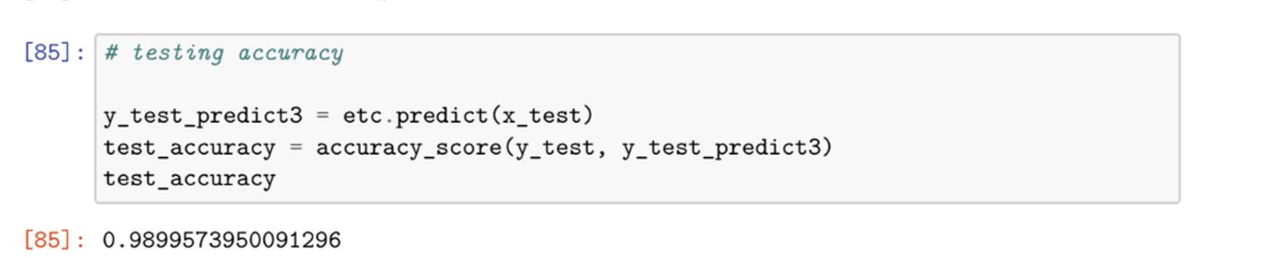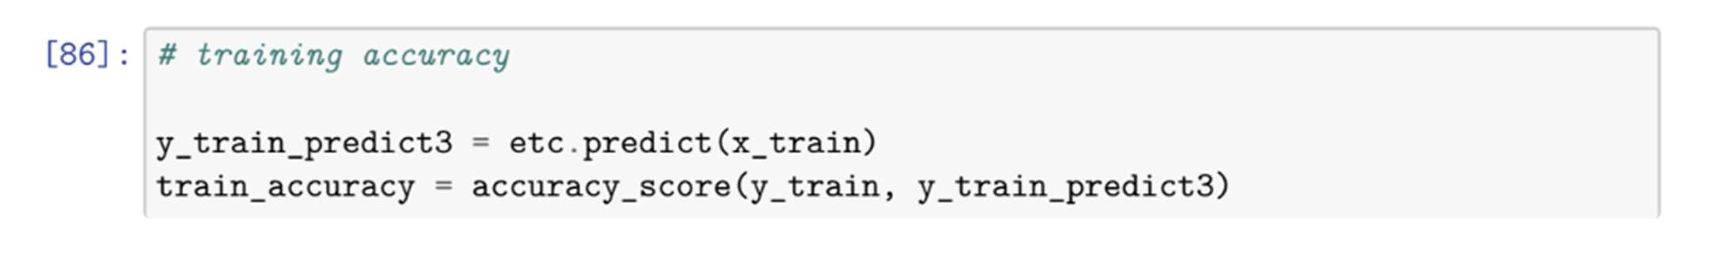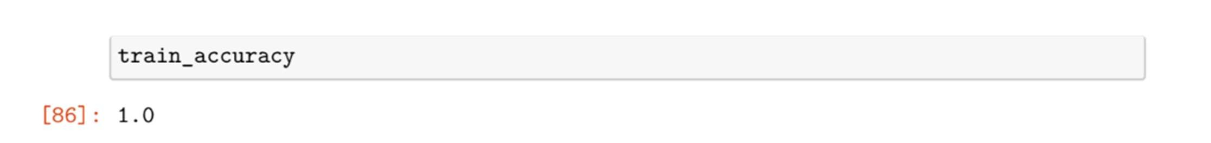

1. Extra Trees Classifier

Similar to Random Forests, Extra Trees builds an ensemble of decision trees but with a difference in the way it selects the splitting thresholds, introducing additional randomness to enhance diversity among the trees and potentially improving accuracy.

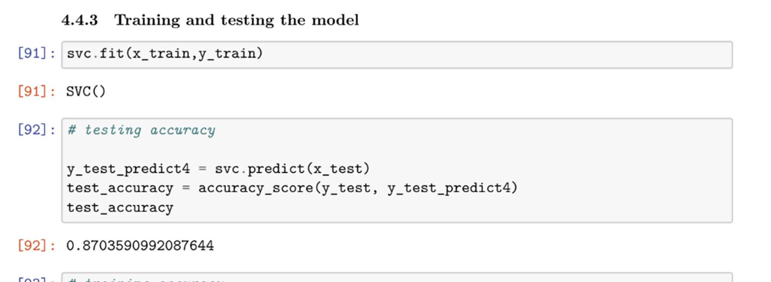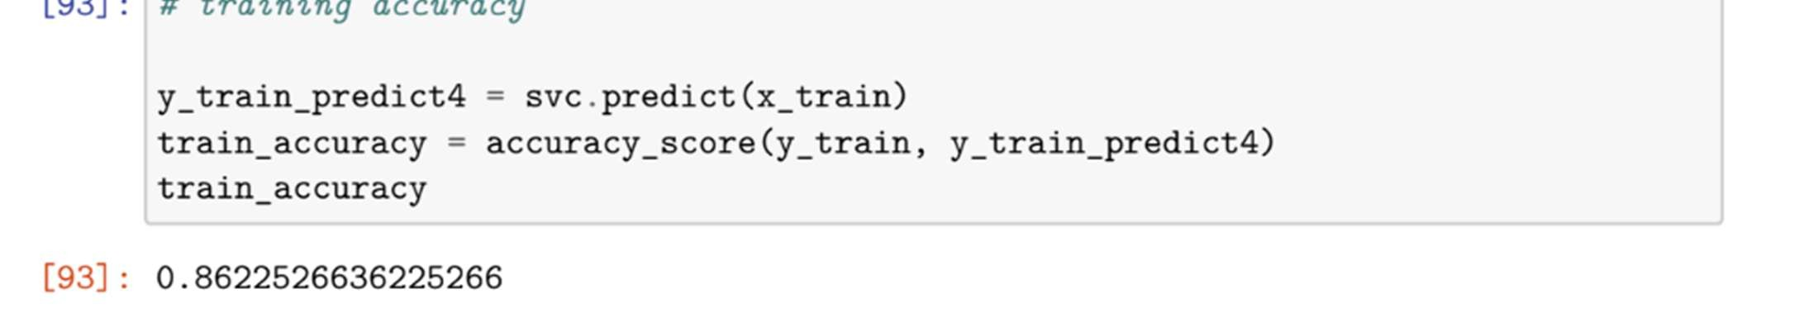

1. XGBoost

XGBoost is an ensemble learning method that combines the predictions of multiple weak models, usually decision trees, to create a strong predictive model. It employs a gradient boosting framework, optimizing the overall model's performance by iteratively adding weak learners.

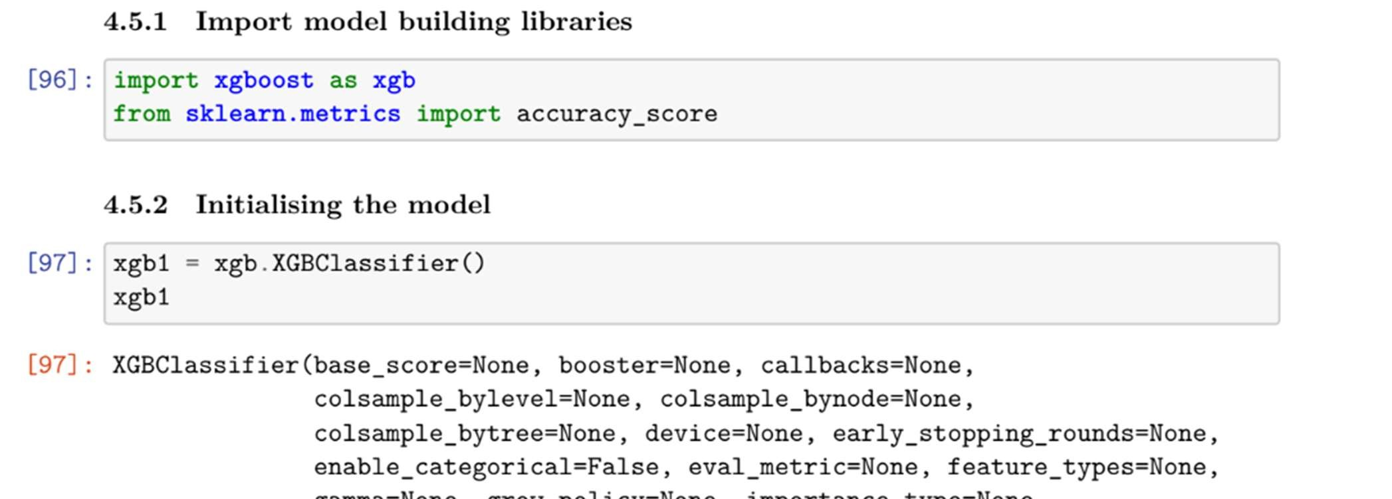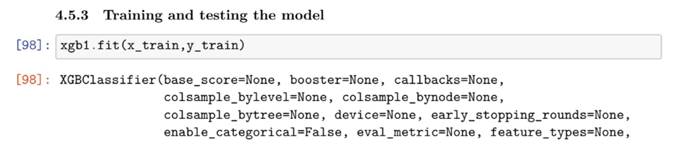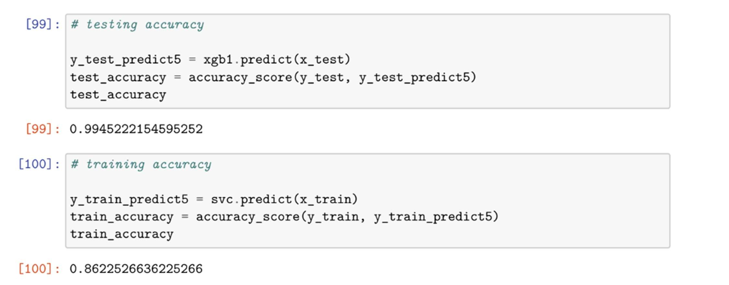

After comparing the testing and training accuracies of all the models, it was found that XGBoost has the best. The first three models are overfitting and the fourth model has a lower testing accuracy compared to the fifth model thus leaving us with XGBoost.

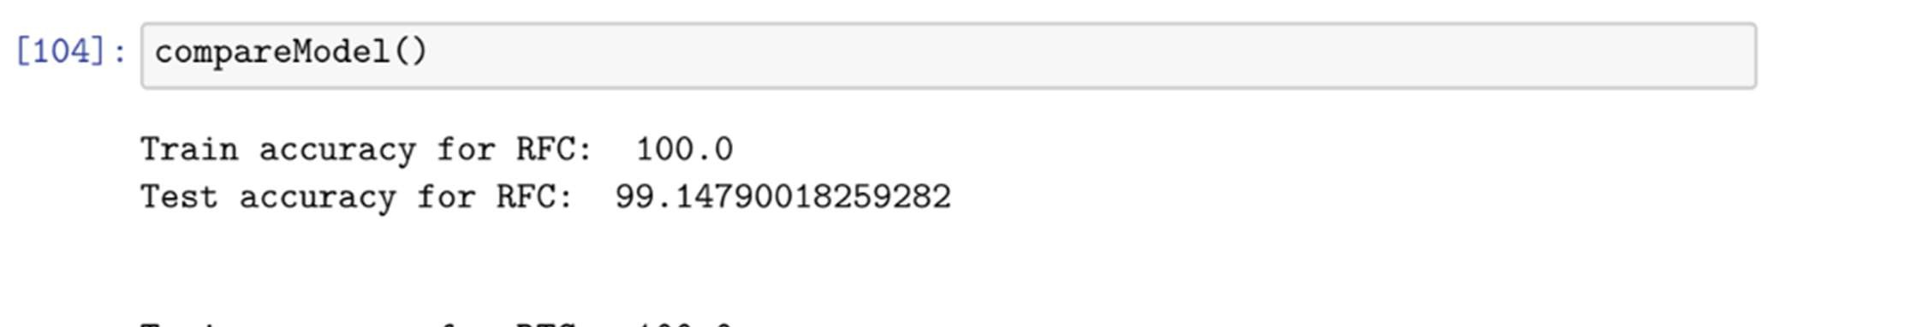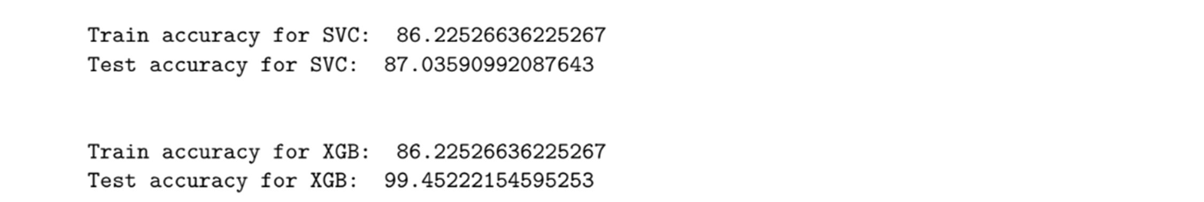

Extreme Gradient Boosting, is an ensemble learning algorithm known for its speed and performance. It sequentially builds a series of weak learners (decision trees) and combines their predictions, iteratively correcting errors to improve accuracy. The algorithm's ability to handle complex relationships within the data and its robustness against overfitting contribute to its effectiveness in accurately identifying fraudulent transactions in the dynamic and nuanced landscape of online payments.

# 8. PERFORMANCE TESTING

https://drive.google.com/file/d/1S-WN3KcSAkdKItk7mYLauLDo9El-afbQ/view?usp=sharing

8.1

Performance Metrics

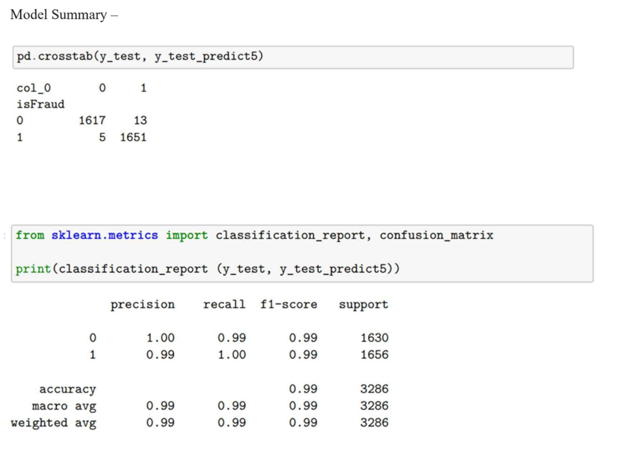

9.

RESULTS

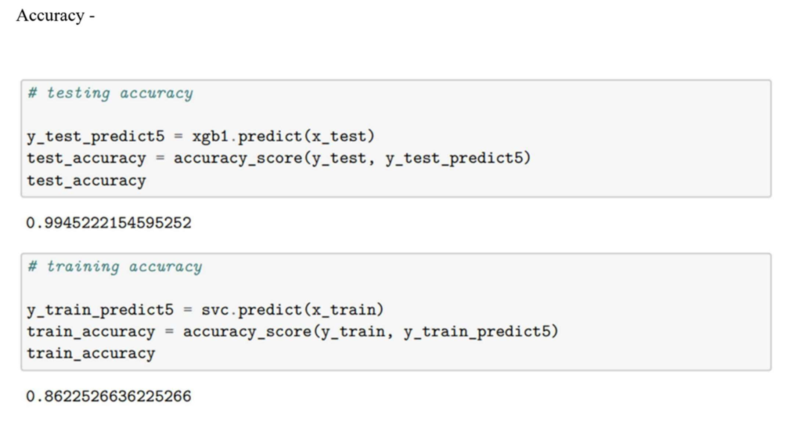

## 9.1 Output Screenshots



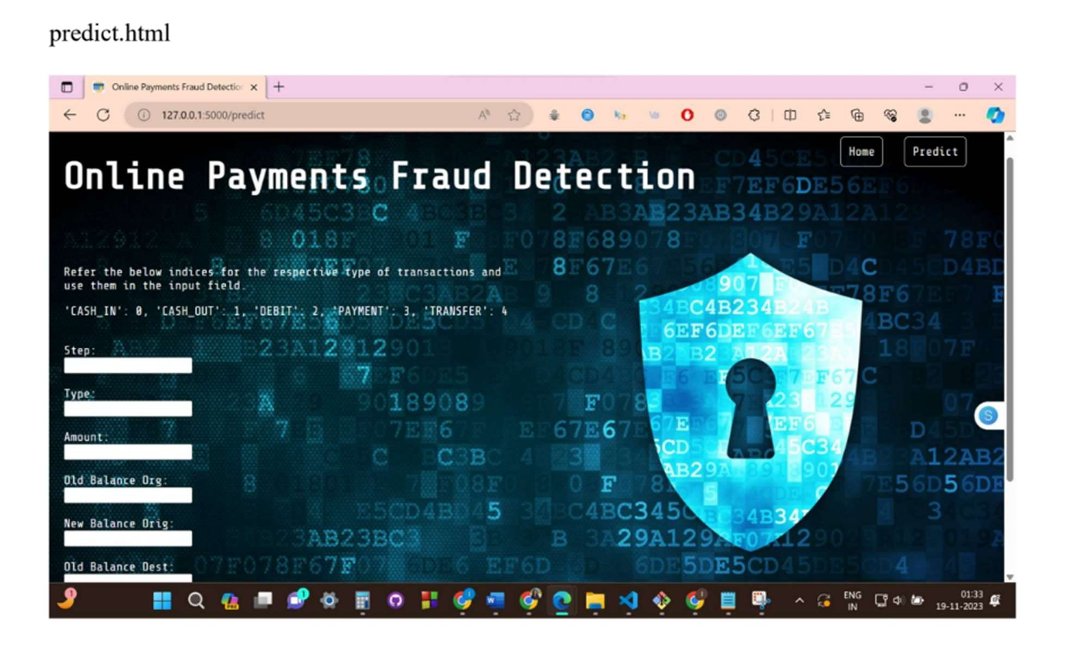



# 10. ADVANTAGES & DISADVANTAGES

Advantages:

## • Accuracy

Machine learning models can achieve high accuracy in identifying patterns indicative of fraud, especially when trained on large and diverse datasets.

## • Real-time Detection

Many machine learning models can operate in real-time, providing immediate responses to potentially fraudulent transactions, contributing to timely mitigation.

## • Adaptability

Machine learning models can adapt to evolving fraud patterns, continuously improving their performance over time as they encounter new data.

## • Automation

Once trained, machine learning models can automate the detection process, reducing the need for manual intervention and enabling scalability in handling large volumes of transactions.

## • Pattern Recognition

Machine learning excels at recognizing complex patterns and relationships within data, allowing for the identification of subtle and non-obvious indicators of fraud.

Disadvantages:

## • False Positives

Machine learning models may generate false positives, flagging legitimate transactions as fraudulent, which can result in inconveniences for users and potential loss of business.

## • Data Quality Dependency

The effectiveness of machine learning models is highly dependent on the quality and representativeness of the training data. Poor-quality or biased data can lead to inaccurate predictions.

## • Adversarial Attacks

Fraudsters may attempt to manipulate machine learning models using adversarial attacks, exploiting vulnerabilities, and potentially undermining the model's effectiveness.

## • Interpretability

Some advanced machine learning models, such as deep neural networks, lack interpretability, making it challenging to understand the rationale behind their decisions, which can be a concern for regulatory compliance.

## • Resource Intensive

Developing, training, and maintaining sophisticated machine learning models for fraud detection can be resource-intensive, requiring significant computational power and expertise.

## • Concept Drift

The dynamic nature of fraud may lead to concept drift, where the model's performance degrades over time as it becomes less representative of the current fraud landscape.

## • Privacy Concerns

The collection and analysis of sensitive data for training machine learning models raise privacy concerns, necessitating careful handling to comply with data protection regulations.

# 11. CONCLUSION

In conclusion, implementing a machine learning model for online payments fraud detection offers a promising avenue to enhance the security and integrity of digital transactions. The advantages, such as high accuracy, real-time detection, and adaptability to evolving fraud patterns, underscore the potential of these models to effectively combat fraudulent activities. However, it is crucial to acknowledge the inherent challenges, including the risk of false positives, dependency on data quality, susceptibility to adversarial attacks, and the resource-intensive nature of model development and maintenance.

Balancing the benefits and drawbacks requires a meticulous approach, incorporating robust data preprocessing, ongoing model monitoring, and continuous adaptation to emerging fraud tactics. Addressing privacy concerns and ensuring compliance with regulations further solidify the ethical foundation of such projects. Ultimately, the successful implementation of a machine learning model for fraud detection hinges on a strategic blend of technological innovation, data quality assurance, and a commitment to user privacy. This project not only seeks to fortify the security of online transactions but also exemplifies the ongoing pursuit of advancements in machine learning to confront the evolving challenges of the digital landscape.

# 12. FUTURE SCOPE

## • Advanced Machine Learning Techniques

Explore and integrate state-of-the-art machine learning techniques and algorithms to further improve the accuracy and adaptability of the fraud detection model. This may involve leveraging deep learning architectures or exploring ensemble methods for enhanced predictive capabilities.

## • Behavioral Analysis

Incorporate advanced behavioral analytics to supplement transaction-based features. Analyzing user behavior patterns, device interactions, and contextual information can enhance the model's ability to identify anomalies and potential fraud indicators.

## • Explainable AI (XAI)

Focus on developing models with improved interpretability and explainability. This ensures that stakeholders, including end-users and regulatory bodies, can understand the decision-making processes of the machine learning model, fostering trust and transparency.

## • Blockchain Integration

Explore the integration of blockchain technology to enhance the security and transparency of transaction records. Blockchain's decentralized and tamper-resistant nature can provide an additional layer of protection against fraud.

## • Continuous Monitoring and Adaptive Learning

Implement more sophisticated mechanisms for continuous monitoring and adaptive learning. This involves developing systems that can autonomously recognize and adapt to new fraud patterns in real-time, reducing the lag between pattern emergence and model adaptation.

## • Collaborative Threat Intelligence

Establish collaborative frameworks for sharing threat intelligence across institutions and industries. This collective approach can enhance the model's ability to recognize emerging fraud trends and improve overall cybersecurity resilience.

## • Examination of Cross-Channel Fraud

Extend the scope of fraud detection to cover multiple channels, including mobile apps, web transactions, and other digital platforms. A comprehensive, cross-channel approach can provide a holistic view of user interactions and potential fraud scenarios.

## • Integration with Regulatory Compliance

Strengthen the integration with regulatory compliance measures, ensuring that the fraud detection system not only meets current standards but also anticipates and adapts to future regulatory requirements.

## • Quantum Computing Preparedness

Consider the impact of emerging technologies, such as quantum computing, on the security of current encryption methods. Preparing the system for potential advancements in computing technology will be crucial for long-term resilience.

## • User-Focused Features

Develop user-focused features such as real-time alerts, personalized risk scores, and user-friendly interfaces to enhance user awareness and engagement in the fraud detection process.

# 13. APPENDIX

* Source Code

https://drive.google.com/drive/folders/1Cf1qemsnkJ-ZgK8F5OHUxnWNRXE8Ba5M?usp=sharing

* GitHub Link   
  <https://github.com/VKarthik5102/Online-Payment-Fraud-Detection>